# Task 4.1

## Windows 8.1 (32-bit)

1 GHz processor or faster with support for PAE, NX, and SSE2  
  
2 GB RAM  
  
20 GB available hard disk space  
  
1366 x 768 screen resolution  
  
DirectX 9 graphics processor with WDDM driver  
  
To use touch, you need a PC that supports multitouch  
  
Internet access (fees may apply)  
  
Microsoft account required for some features  
  
Watching DVDs requires separate playback software  
  
Windows Media Center license sold separately

## Windows 8.1 (64-bit)

1 GHz processor or faster with support for PAE, NX, and SSE2  
  
2 GB RAM  
  
20 GB available hard disk space  
  
1366 x 768 screen resolution  
  
DirectX 9 graphics processor with WDDM driver  
  
To use touch, you need a PC that supports multitouch  
  
Internet access (fees may apply)  
  
Microsoft account required for some features  
  
Watching DVDs requires separate playback software  
  
Windows Media Center license sold separately

# 4.2 Windows 8.1 Installation

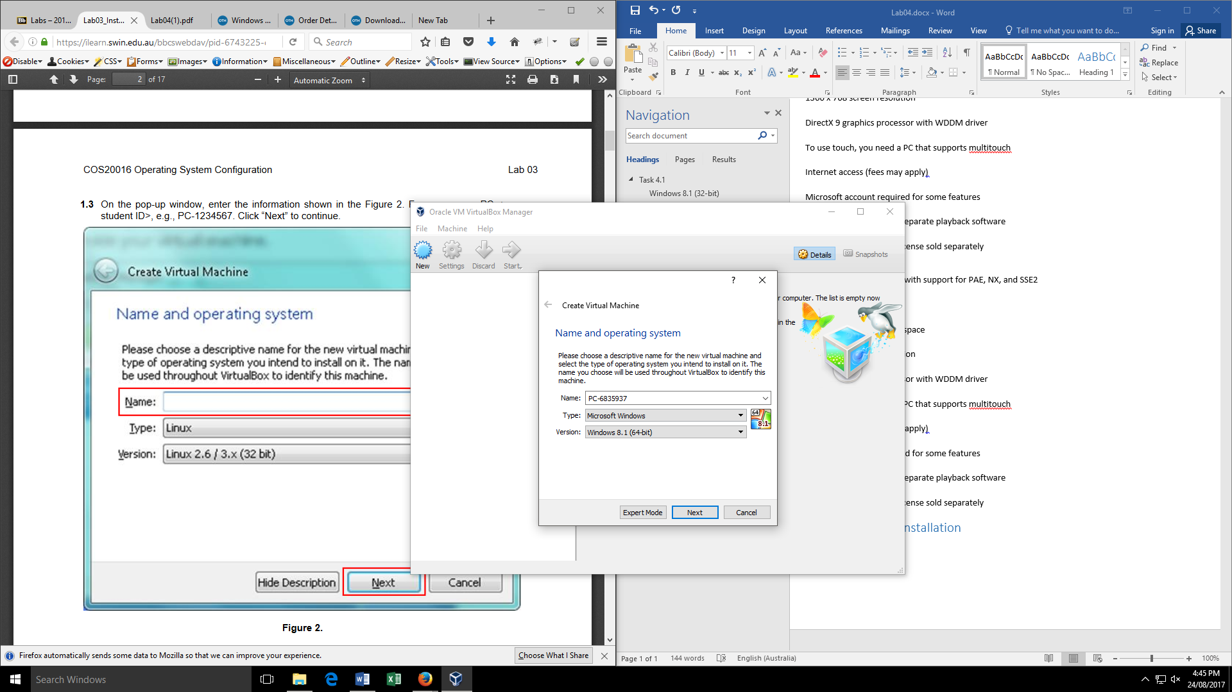

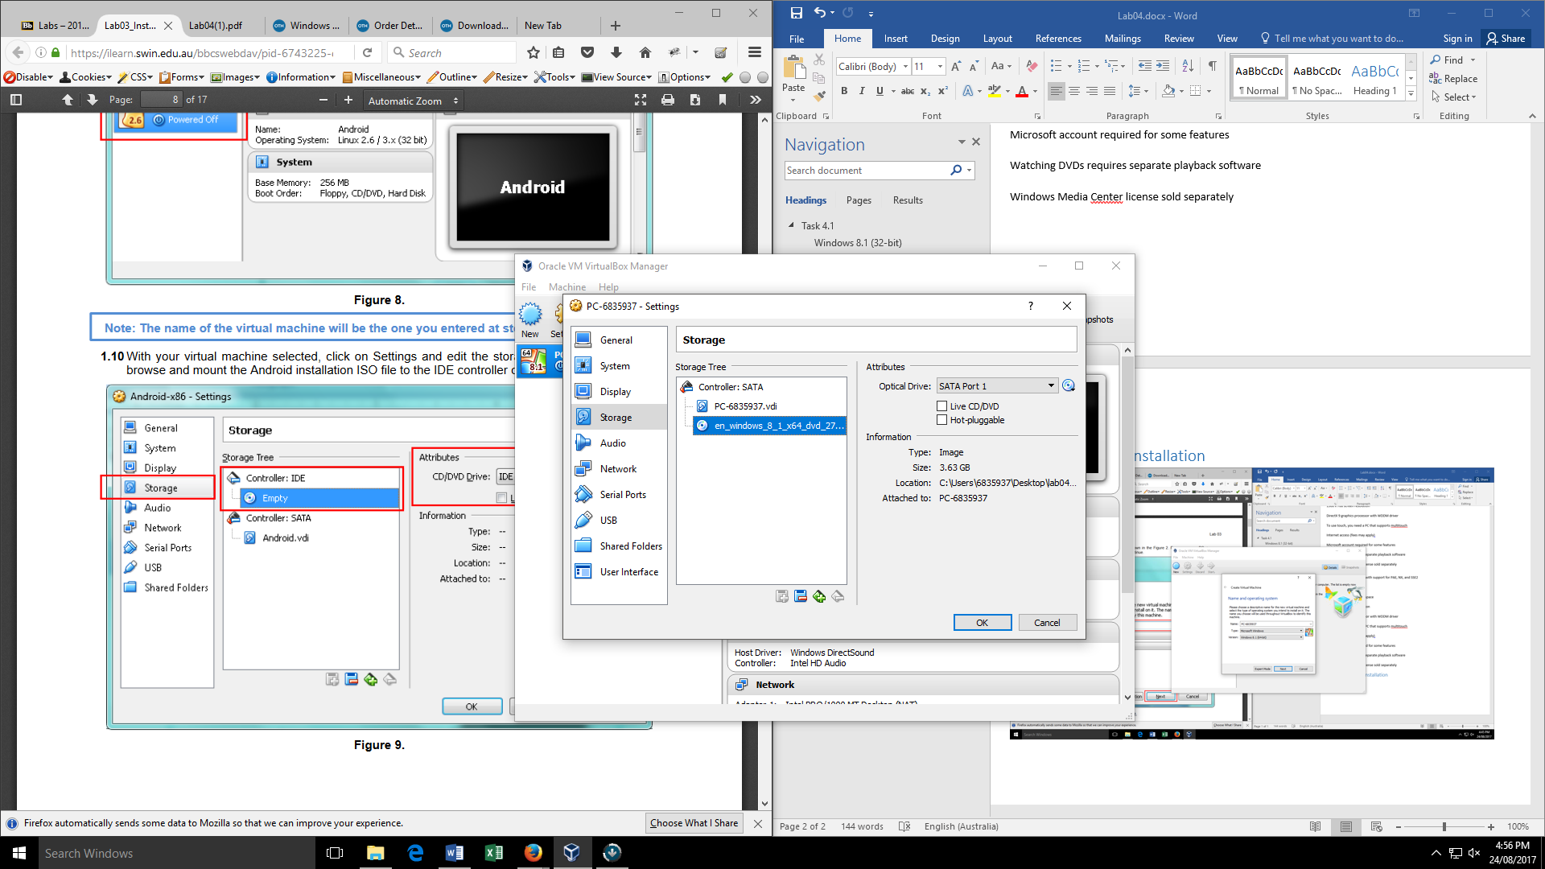

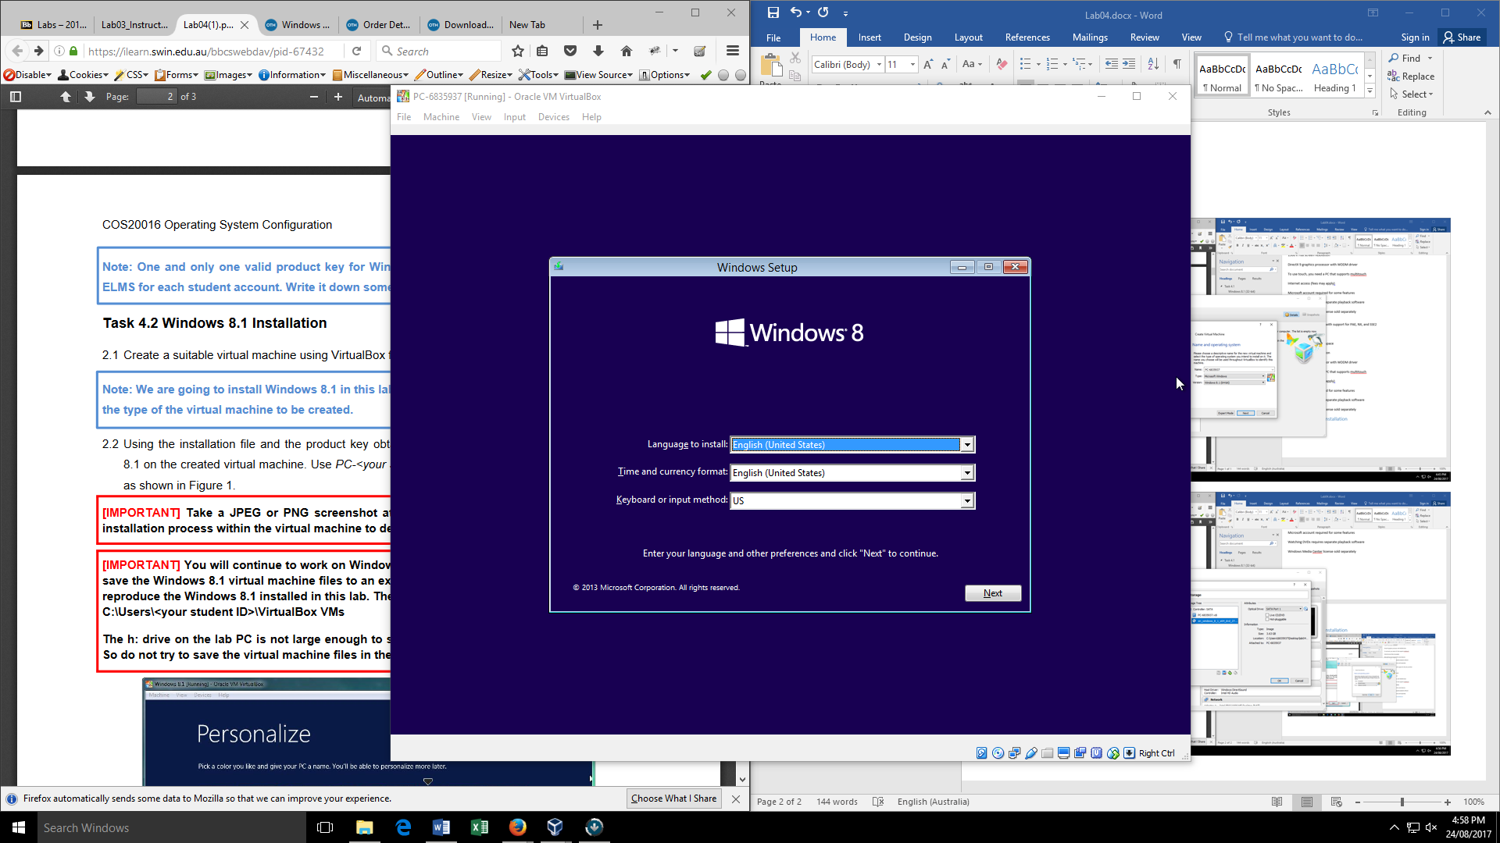

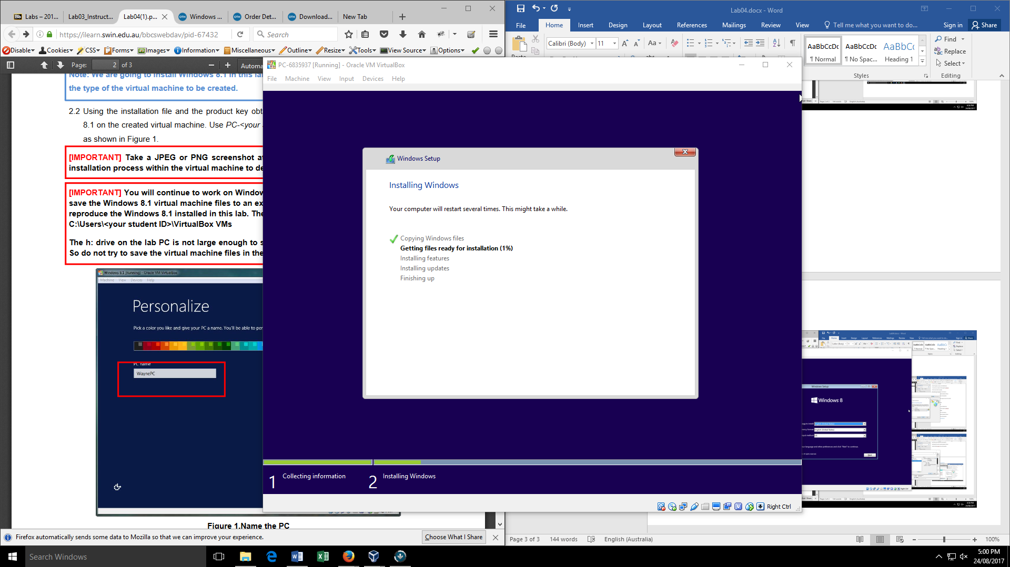

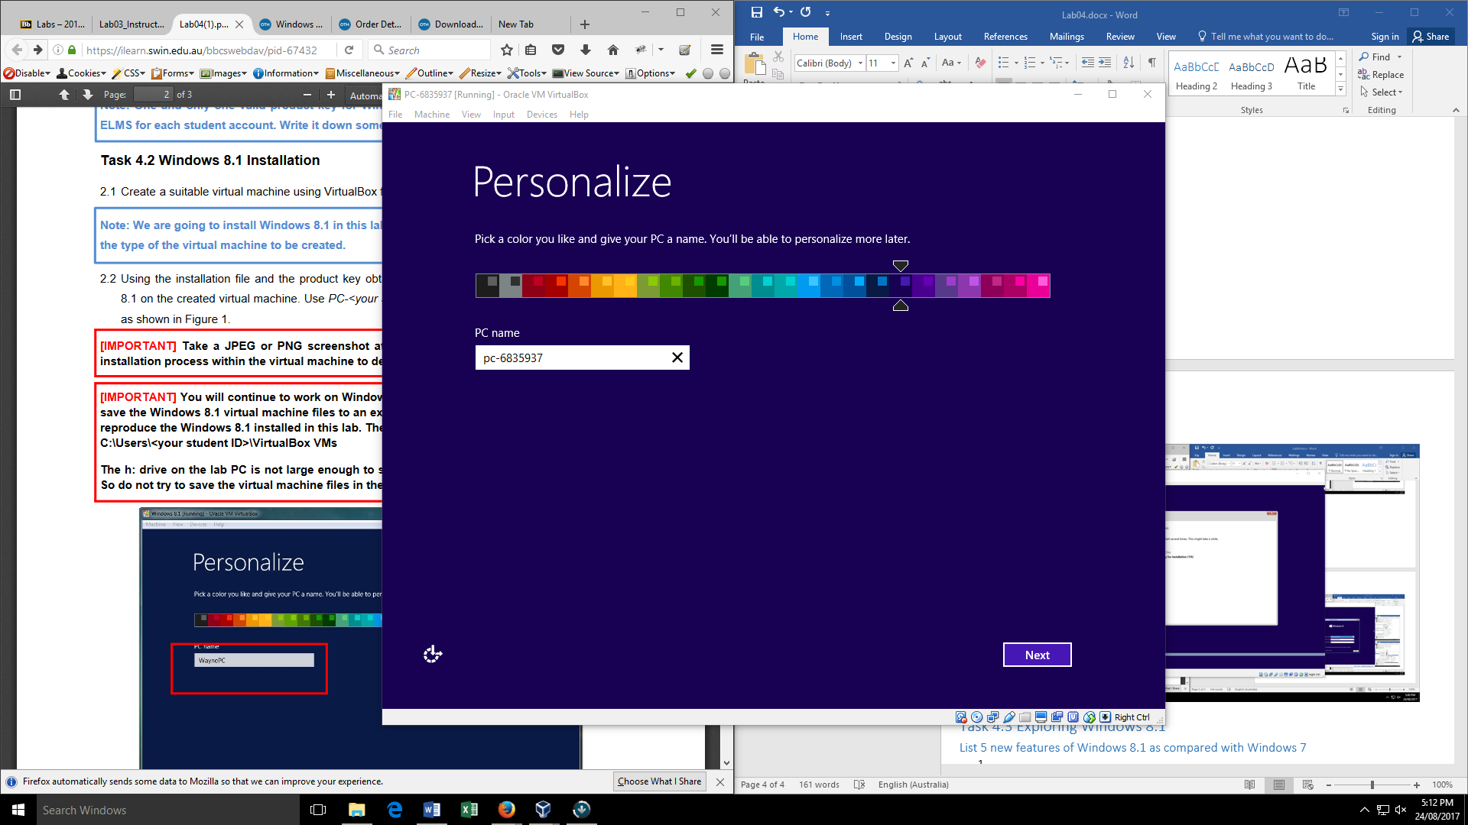

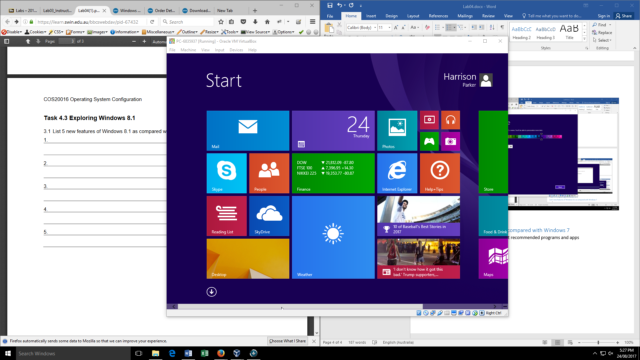

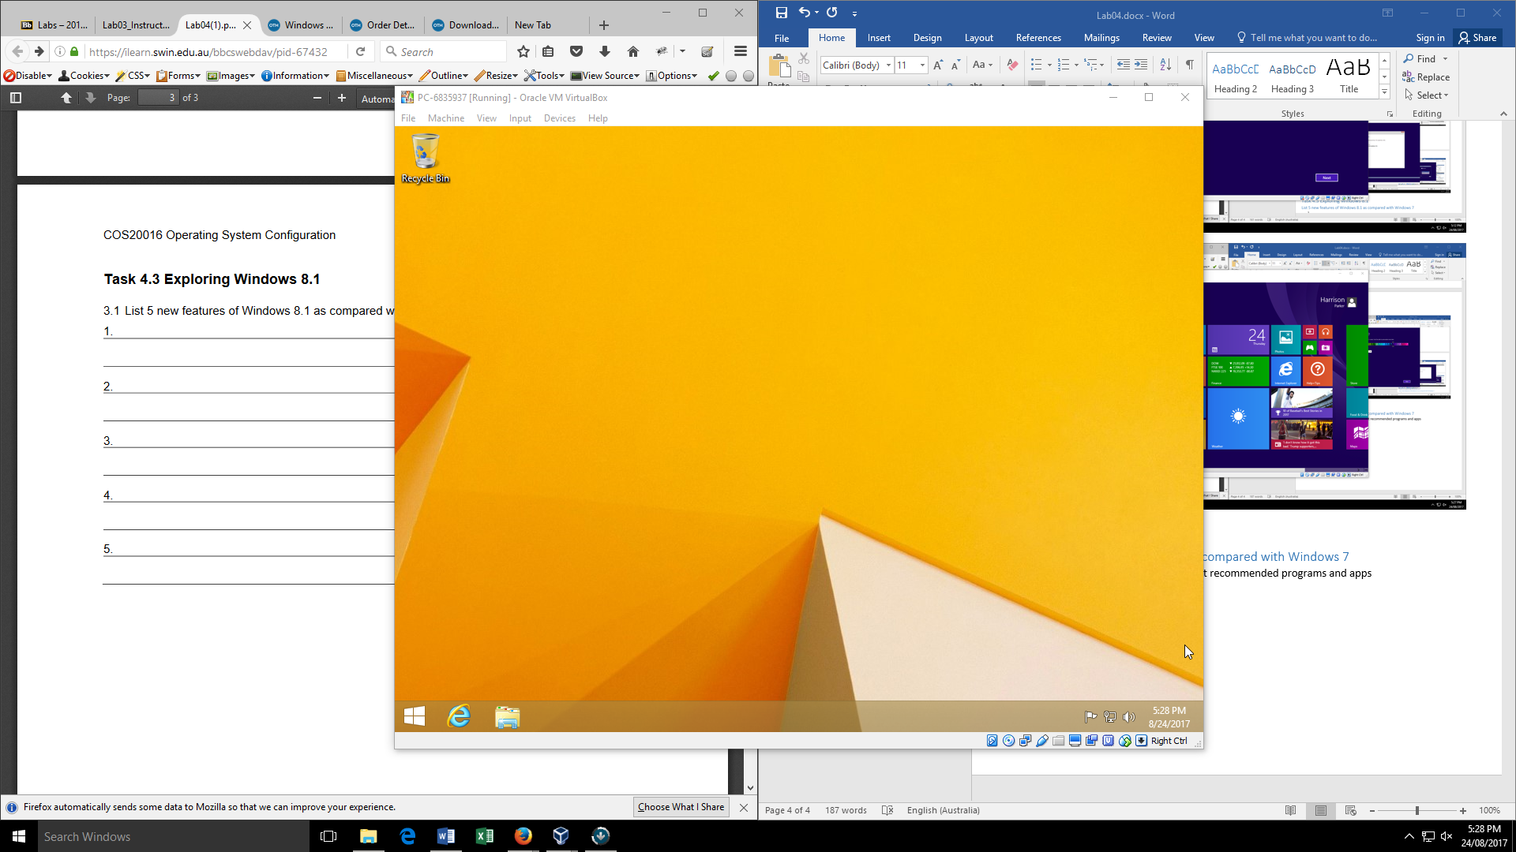

# Task 4.3 Exploring Windows 8.1

## List 5 new features of Windows 8.1 as compared with Windows 7

1. Start menu – can zoom in and out, list recommended programs and apps
2. Apps
3. SkyDrive
4. Window styles changed.
5. Log off menu changed.